

**SEAMEO BASIC EDUCATION STANDARDS (SEA-BES) PHASE 2- TEACHING TO TRANSFORM: 21ST CENTRURY SKILLS AND**

**DESIGN THINKING IN STEM CONTEXTS**

**FEEDBACK FORM FOR THE STEM PLANNING AND DESIGN LEARNING (PaDL) FRAMEWORK**

1. **Design Panning Model for Teachers : Please study the diagram below and give your comments and suggestions on the table. Please refer to the draft module for the finer details of this framework/model.**

Ethical Use of Knowledge

Social Awareness

Design Learning Process for Students

Planning for Teaching

Reflection

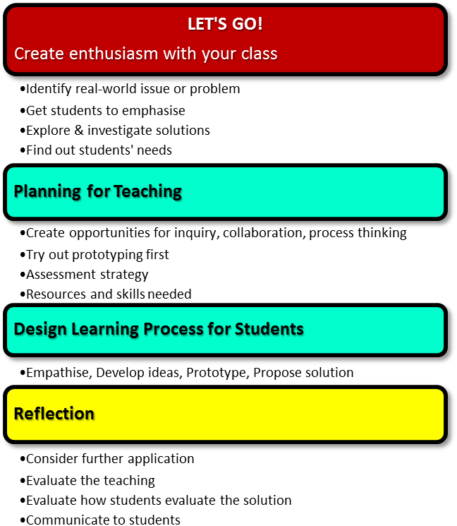

|  |  |  |
| --- | --- | --- |
| **Step/Cycle of the Model** | **Comments** | **Suggestions** |
| 1. **Let’s Go! – Create enthusiasm with your class** |  |  |
| 1. Why create enthusiasm |  |  |
| 1. How to create enthusiasm |  |  |
| 1. Connections: ethical use of knowledge and social awareness |  |  |
| 1. What is Ethical use of knowledge and social awareness |  |  |
| 1. Why have ethical and social awareness |  |  |
| 1. How to behave ethically and with social awareness |  |  |
| 1. **Planning for Teaching and Design Learning Process for Students** |  |  |
| 1. Connections: Ethical use of knowledge and Social awareness |  |  |
| 1. What is Planning for teaching and Design learning process for students |  |  |
| 1. Why students use the Design learning process |  |  |
| 1. How to plan for teaching |  |  |
| 1. **Reflection** |  |  |
| a. Connections: Planning and Design learning process for students - Reflections |  |  |
| b. What is reflection |  |  |
| c. Why reflect |  |  |
| 1. How to reflect |  |  |
| 1. Iteration and making the process your own |  |  |

1. **Design Learning Process for Students: Please study the diagram below and give your comments and suggestions on the table. Please refer to the draft module for the finer details of this framework/model.**

|  |  |  |
| --- | --- | --- |
| **Step/Cycle of the Model** | **Comments** | **Suggestions** |
| 1. **Empathising** |  |  |
| 1. What is empathizing |  |  |
| 1. Why include empathy |  |  |
| 1. How to empathise |  |  |
| 1. Transition: Empathising to Developing Design Ideas |  |  |
| 1. **Developing Design Ideas** |  |  |
| 1. What is developing design ideas |  |  |
| 1. Why develop design ideas |  |  |
| 1. How to develop design ideas |  |  |
| 1. Transition: Developing Design Ideas to Prototyping/Modelling |  |  |
| 1. **Prototyping/Modelling** |  |  |
| 1. What is prototyping/modelling |  |  |
| 1. Why build a prototype model |  |  |
| 1. How to create new knowledge |  |  |
| 1. Transition: Prototyping/Modelling to Proposing Solution |  |  |
| 1. Proposing Solution |  |  |
| 1. What is proposing solution |  |  |
| 1. Why propose a solution |  |  |
| 1. How to propose a solution |  |  |
| 1. Iteration and making the process your own |  |  |

**Other feedback:**

**NOTE: PLEASE SUBMIT THIS FEEDBACK FORM ON OR BEFORE 30 JUNE 2020. THANK YOU VERY MUCH!**

Submitted by: _________________

Designation/Position: _________________

Office/Institution: ________________

Email Address:

Country: ___________________

Date: _________